**--Exercise 3: Stored Procedures**

**Scenario 1:** The bank needs to process monthly interest for all savings accounts.

* + **Question:** Write a stored procedure **ProcessMonthlyInterest** that calculates and updates the balance of all savings accounts by applying an interest rate of 1% to the current balance.

**--Setp1: Database created and listed**

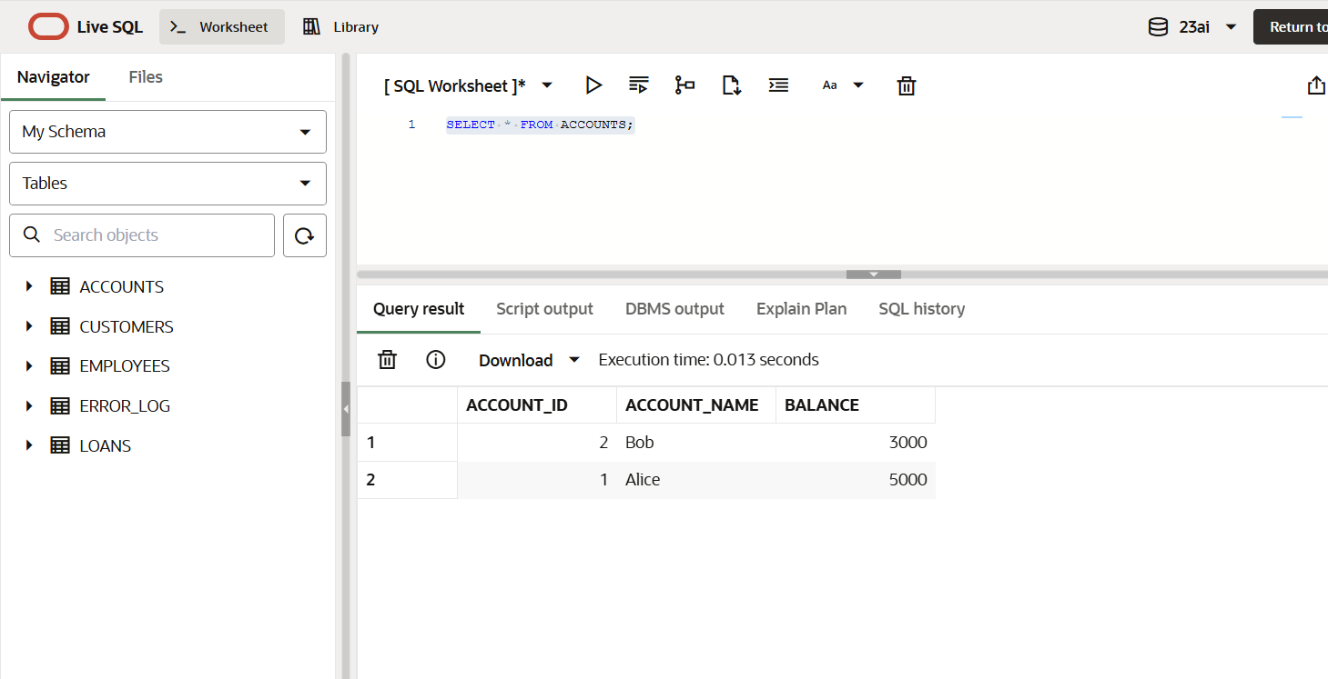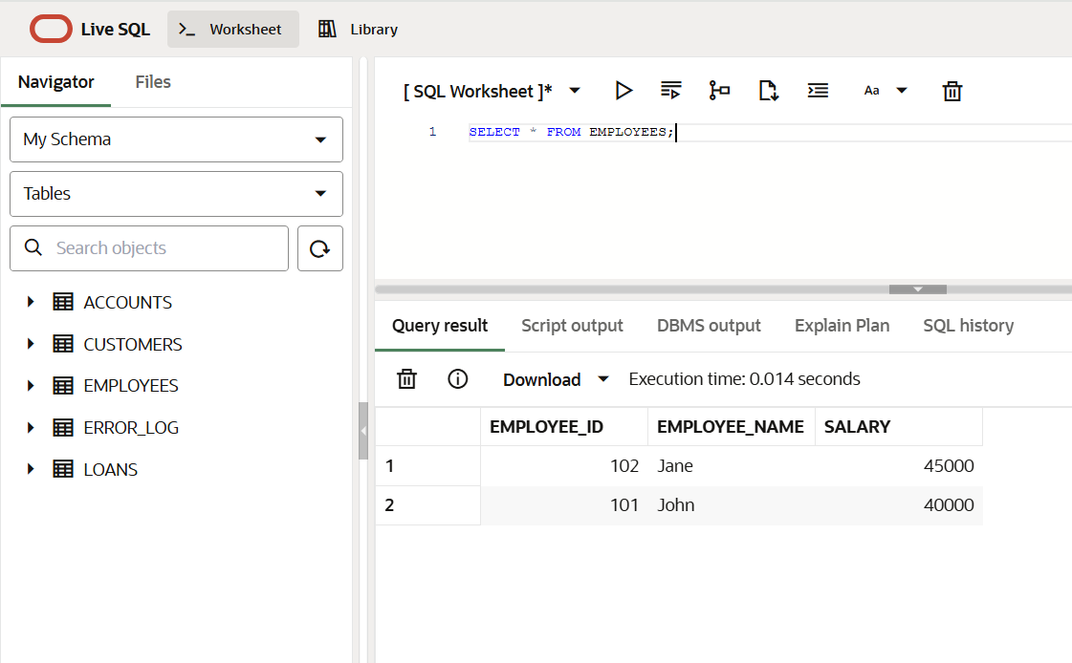

**--Step2: Code**

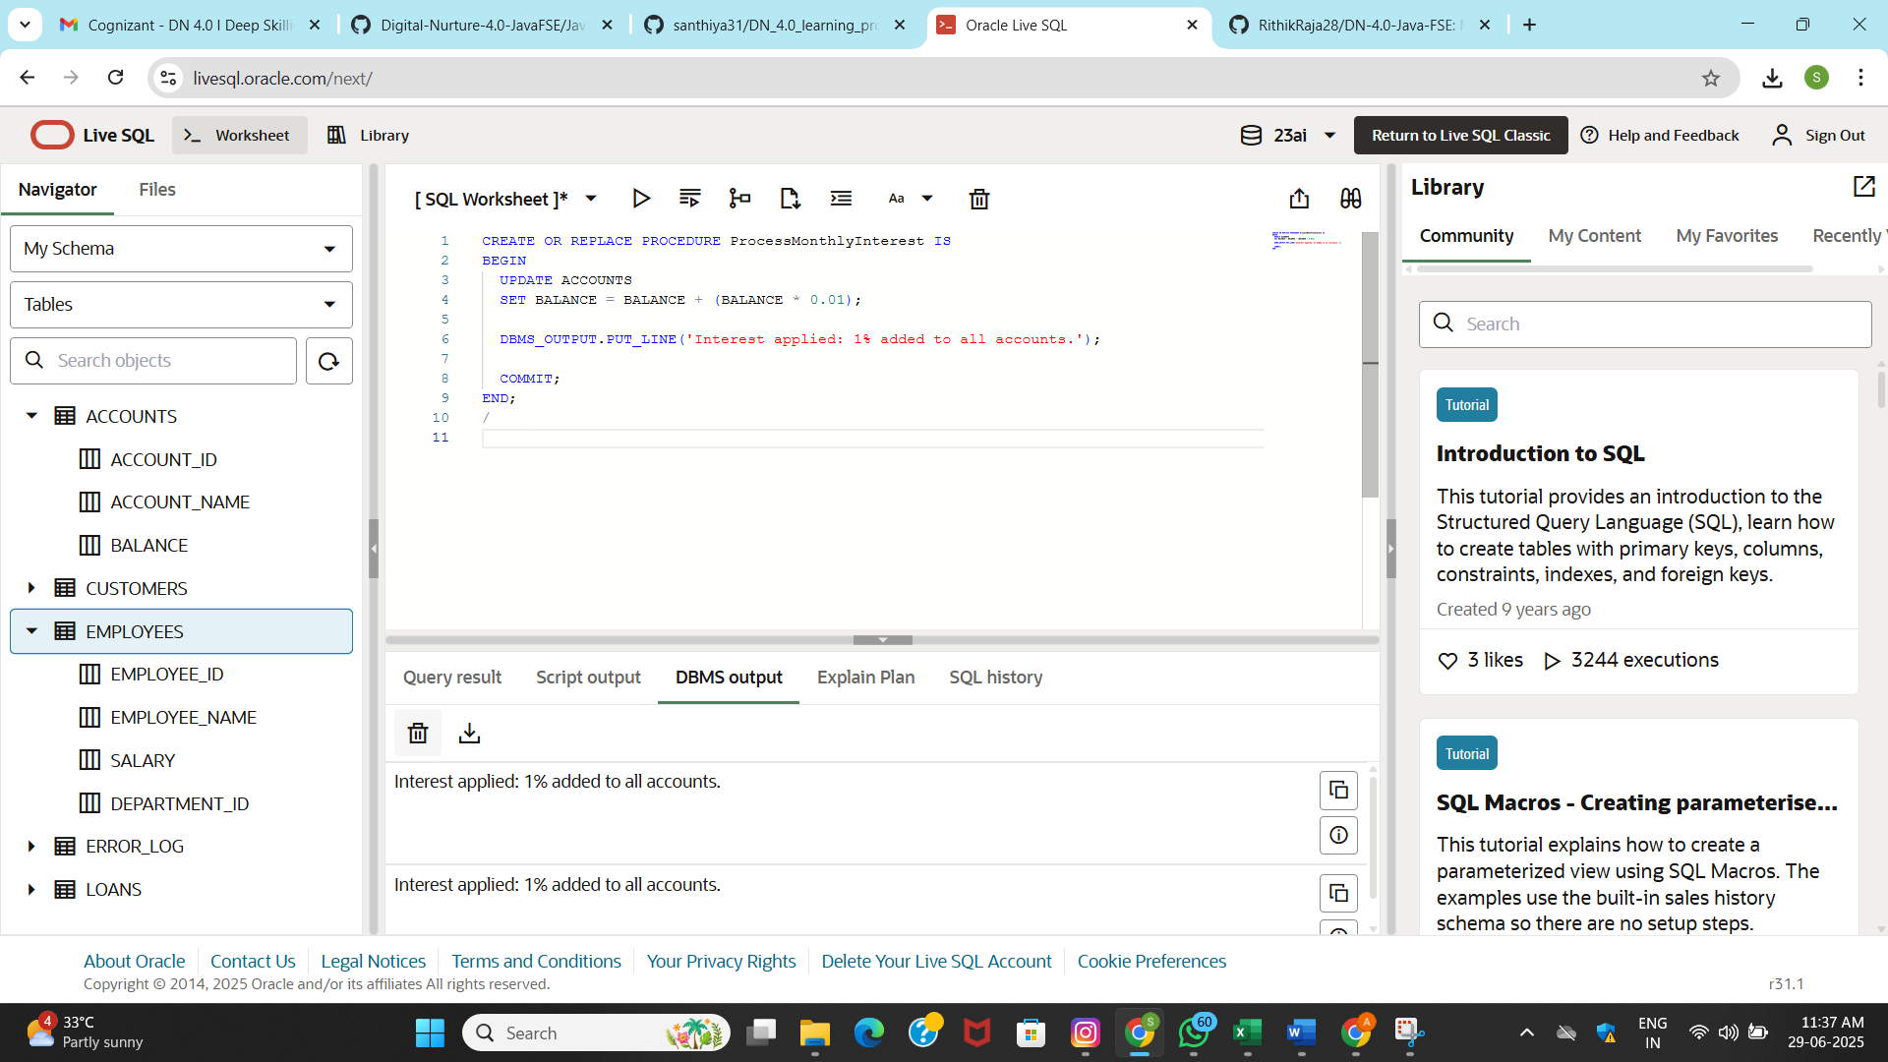

**--Step3: Execute procedures**

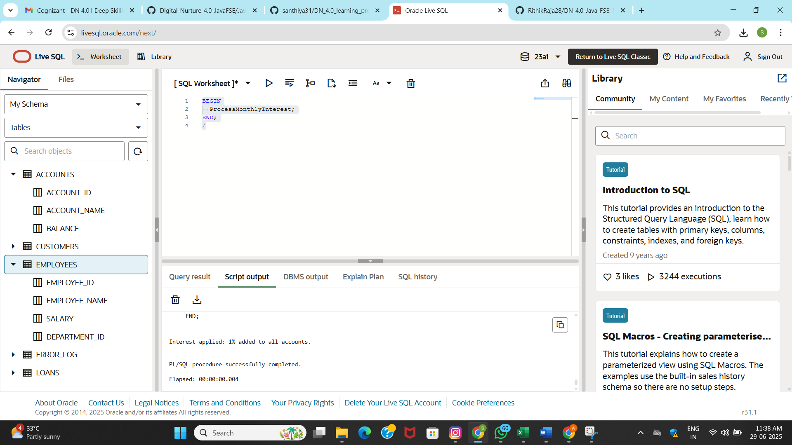

**OUTPUT:**

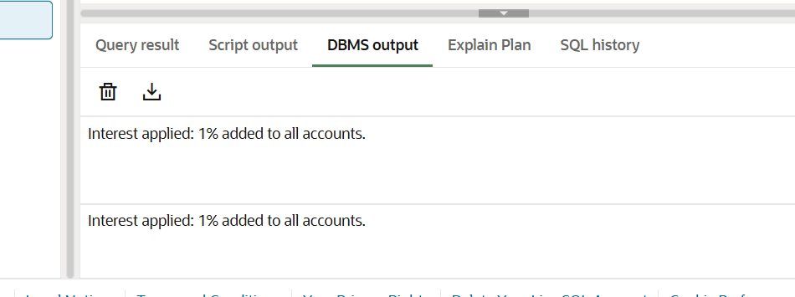

**Scenario 2: The bank wants to implement a bonus scheme for employees based on their performance.**

* + **Question: Write a stored procedure UpdateEmployeeBonus that updates the salary of employees in a given department by adding a bonus percentage passed as a parameter.**

**--Step 1: Code**

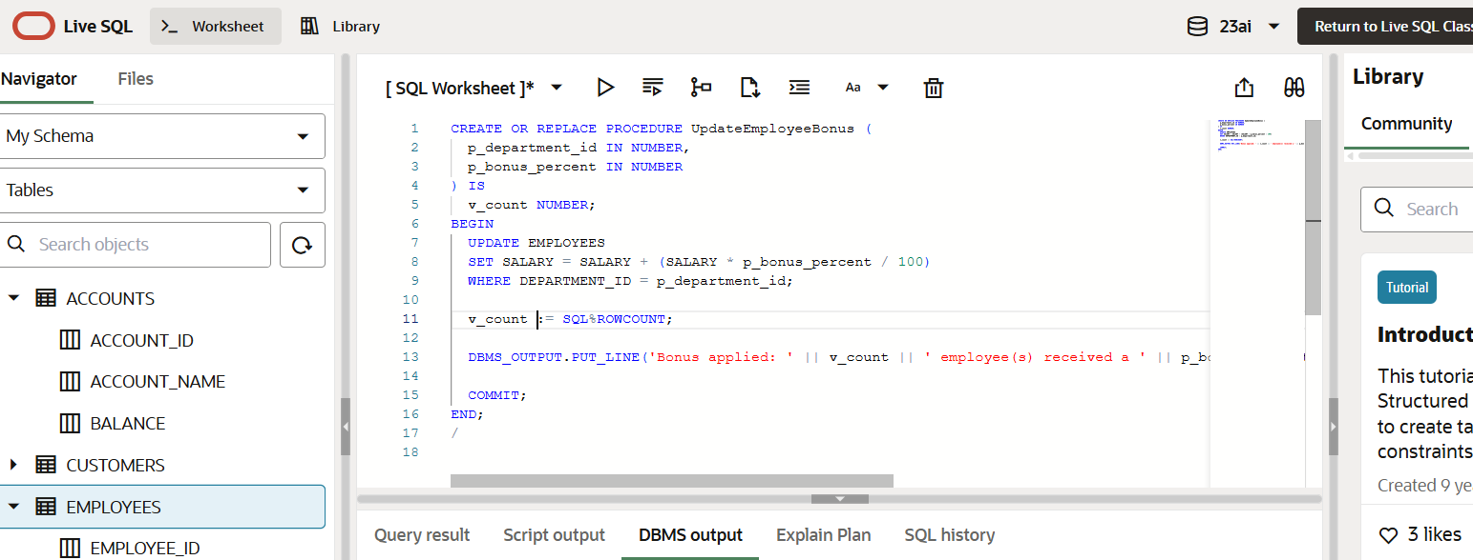

**--Step2: Execute Procedure**

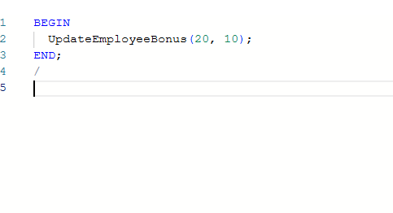

**OUTPUT:**



**Scenario 3: Customers should be able to transfer funds between their accounts.**

* + **Question: Write a stored procedure TransferFunds that transfers a specified amount from one account to another, checking that the source account has sufficient balance before making the transfer.**

**--Step1:Code**

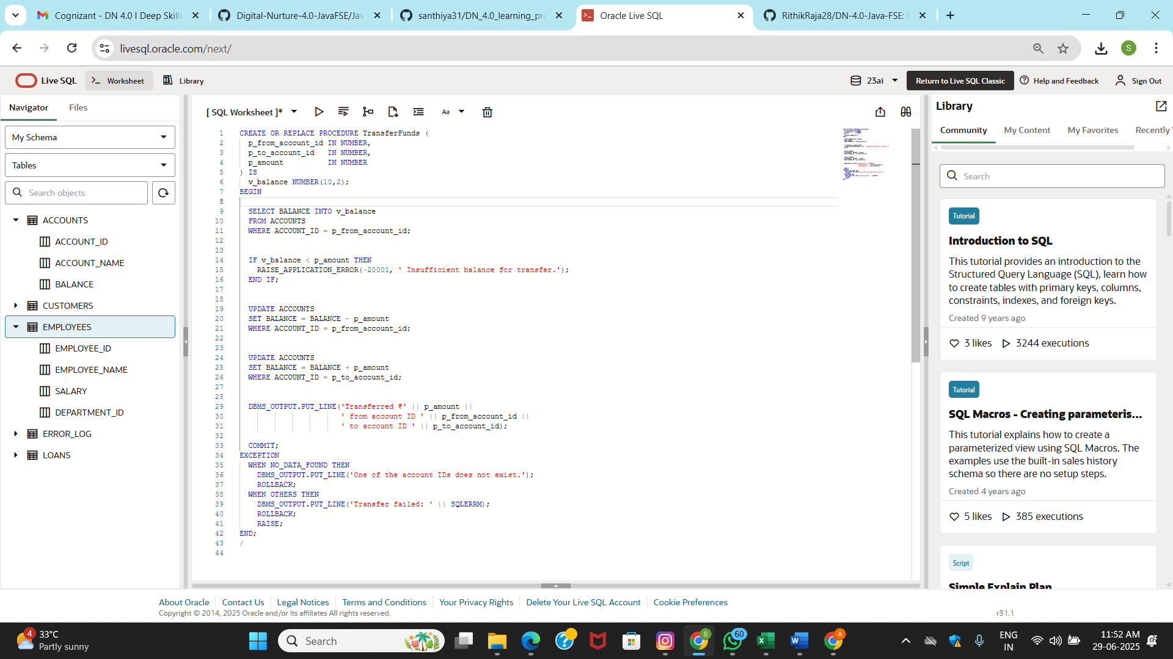

**--Step2:Execute call**

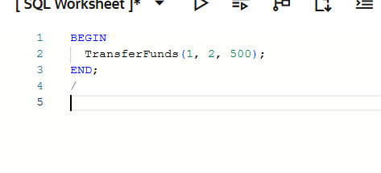

**OUTPUT:**

